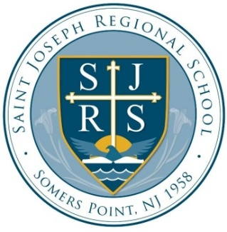
2024-2025 School Year Yearbook
Order Form

- Cost of the Yearbook is $38 per copy
- Cash or Check (Saint Joseph Regional School/SJRS) accepted
- A limited number of yearbooks have been ordered
- Orders will be filled on a first received basis
- Yearbooks will be available in early June

TO ORDER THE SJRS YEARBOOK, complete the information below and return with payment ($38 per copy), in an envelope marked “YEARBOOK ORDER” to the school office.
------------------------------------------------------------------------------------
2024-2025 YEARBOOK

STUDENT NAME: _________________________________________
GRADE/TEACHER: _______________________________________
Thank You for your Order!

